**Tableau Project**

**Data Source**

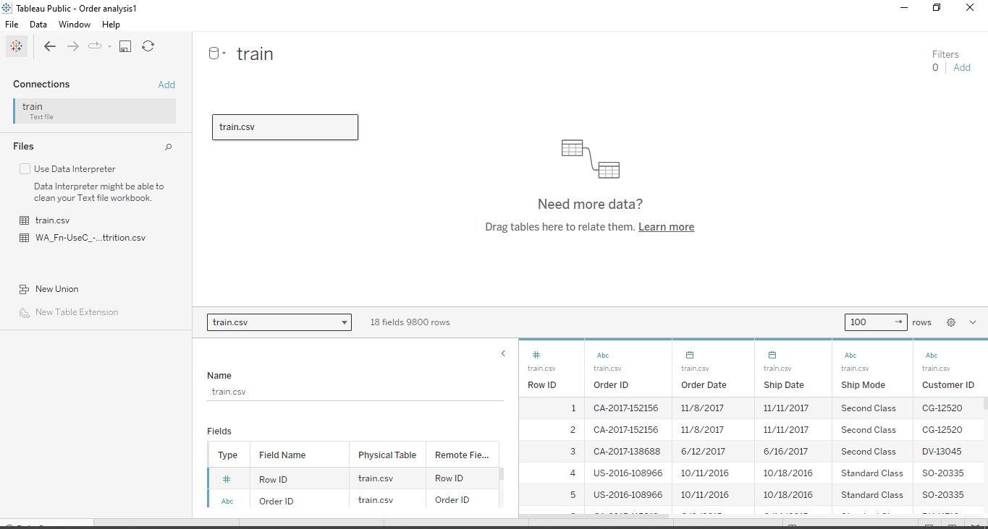

Fig 1: Data for analysis

Source: Self-built in tableau dashboard

**Analysis Begins**

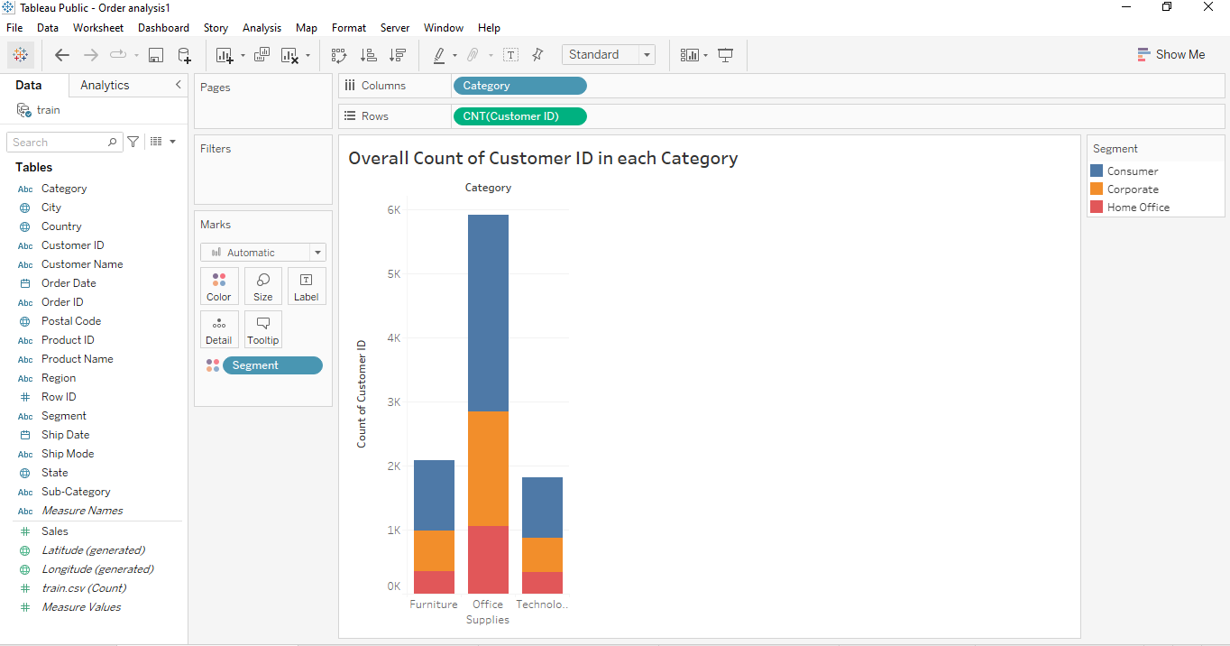

Fig 2: Count of Customer ID for each Category

Source: Self-built in tableau dashboard

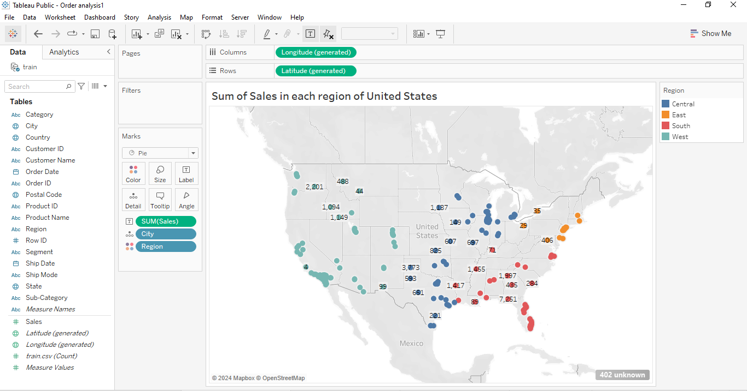

Fig 3: Sum of sales in each City of USA

Source: Self-built in tableau dashboard

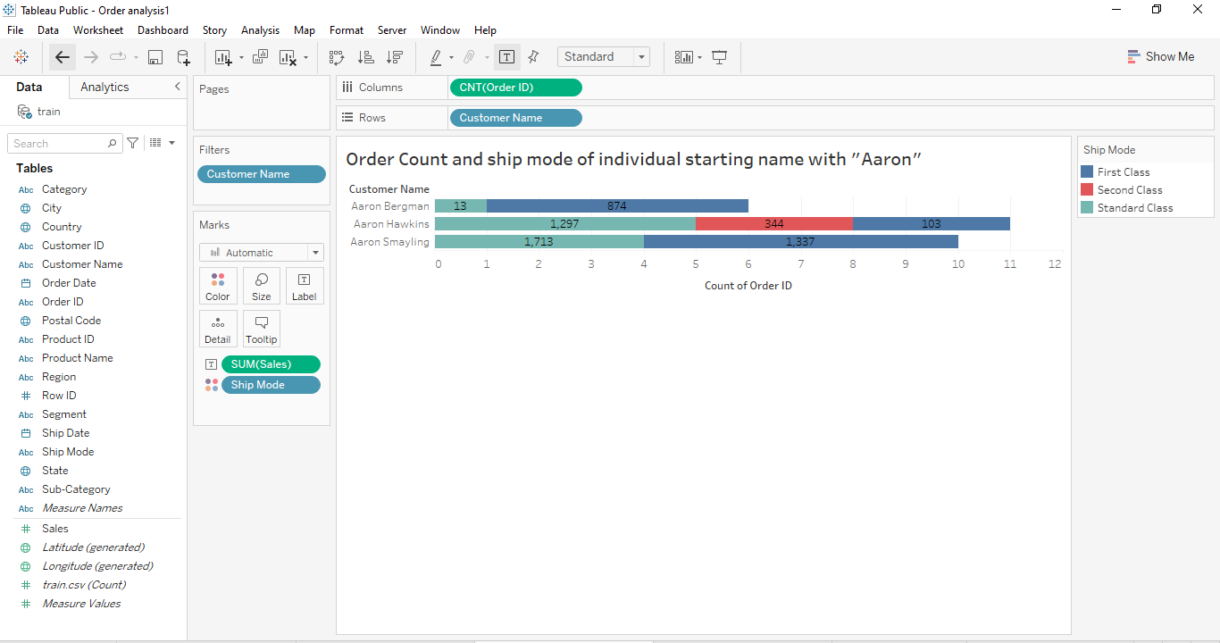

Fig 4: Sum of sales in each Ship mode

Source: Self-built in tableau dashboard

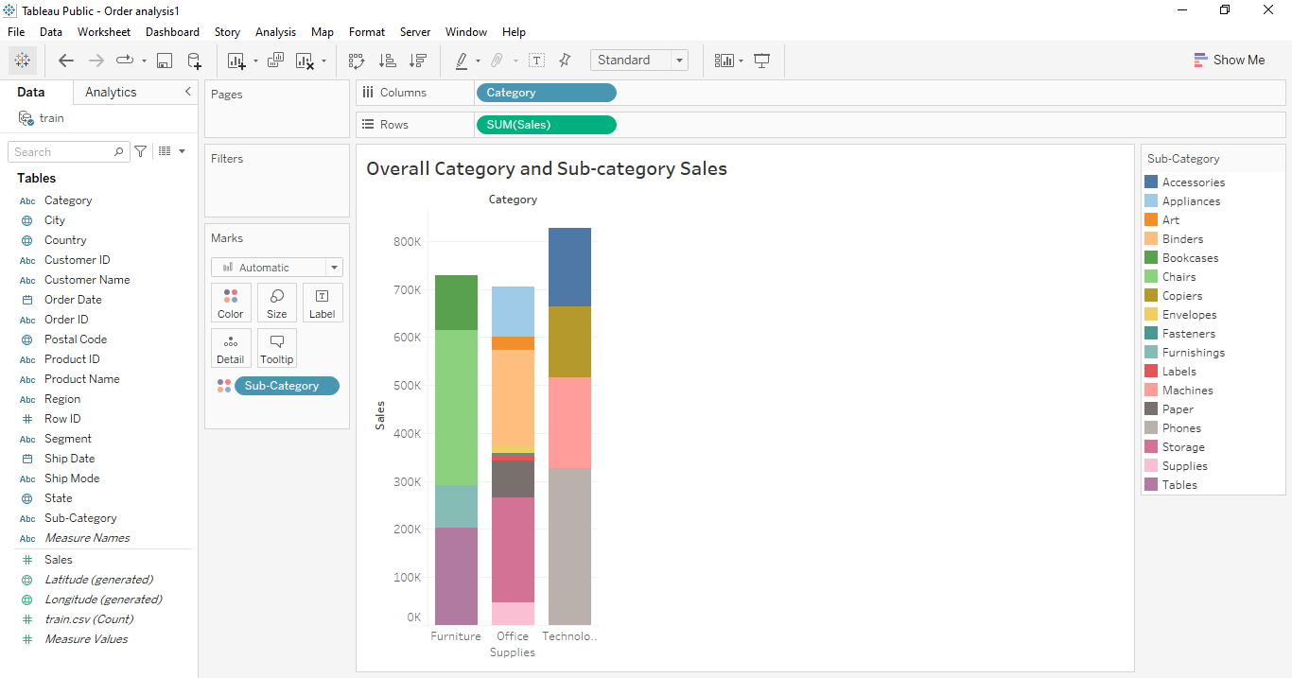

Fig 5: Overall sales of Sub-category in each category

Source: Self-built in tableau dashboard

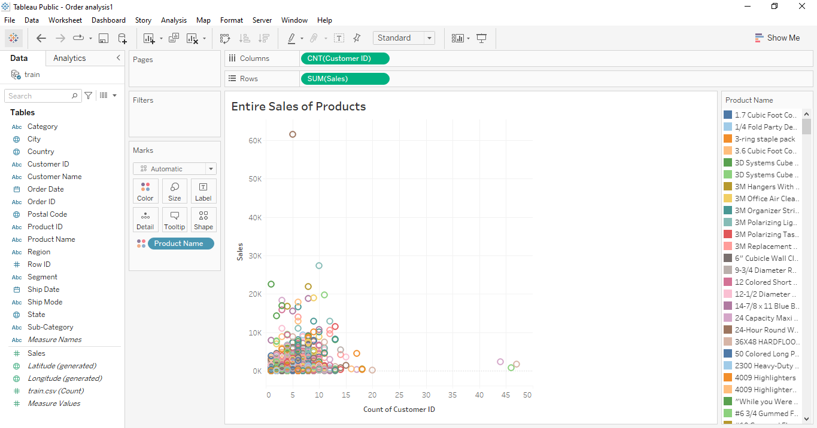

Fig 6: Sum of sales for each product

Source: Self-built in tableau dashboard

**Final working Dashboard**

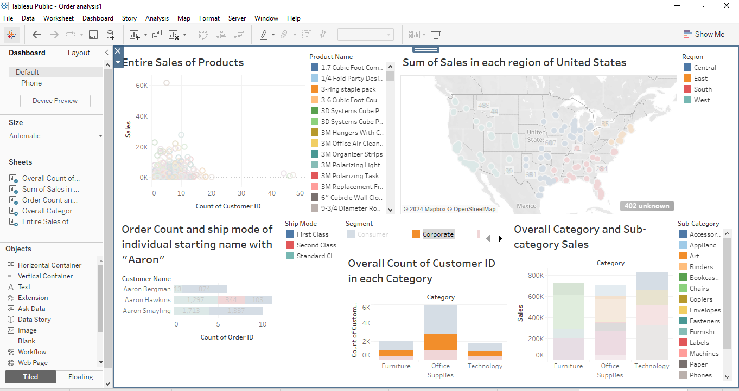

Fig 7: Working dashboard with filters

Source: Self-built in tableau dashboard